Herbivory Assay (“Weedpops”)

v 0.0.4

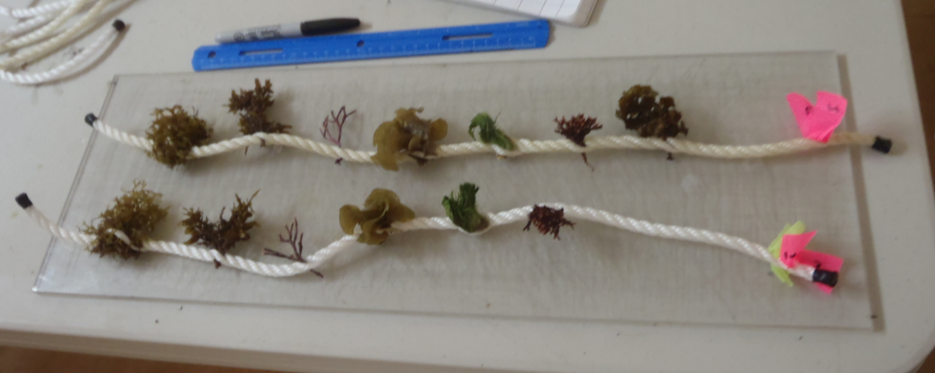

# Introduction

Herbivory is a key process, linking primary producers to the rest of the food web, influencing community composition and diversity, and can mediating phase shifts between alternate states in marine ecosystems (*e.g.*, algal- vs. coral-dominated reefs). To quantify herbivory rates, this protocol describes the ‘Weedpop’ assay (adapted from Hay 1981, Rasher & Hay 2013), intended primarily for application in tropical regions. This method deploys a suite of macroalgae and seagrasses (hereafter ’plants’) representing functional groups found across the tropics, [along with a universal standard bait against which they can be compared]. While the species of plant ‘bait’ differ geographically, one or more members of each functional group should be available at most sites. Herbivory is measured as the loss of baits after 1 and 24 h. The assay produces estimates of both overall rate of herbivory rate and the degree of feeding generalism versus specificity of the local herbivore assemblage.

Optionally, video can be recorded during the first hour of deployment to provide more detailed data on feeding rates (number of bites taken on each bait), as well as the identity and approximate size of the herbivores respnsible. These data further link properties of the herbivore assemblage to herbivory rates, but require greater post-processing time.

Additional copies of this protocol, field datasheets, data entry templates, instructional videos, literature, and more can be found on the MarineGEO protocol website: <https://marinegeo.github.io>.

# Measured Parameters

## This assay determines herbivory rates and feeding selectivity, measured as:

* Number and identity of plant baits lost after 1 h
* Number and identity of plant baits lost after 24 h

Optionally, underwater video footage can record herbivore community properties, measured as:

* Species or taxonomic identity and body size (convertible to body mass) of herbivores feeding on baits
* Herbivore community diversity and biomass

# MarineGEO Requirements

*Frequency*: At least annually

Personnel: 2 people min for dive operations

Time: Preparation: 1 person x 2-3 hours.

Field work: 2 people x 0.5-1 day

Post processing: N/A (or up to 1 person x 2-3 month for videos)

Data processing: 1 person x 2-4 hrs

Replication: 25 Weedpops (each with up to 6 functional groups + 1 standard control)

## Materials:

* 6.5 m ¼- to ¾-inch 3-strand twisted nylon rope
* Cutting tool: rope cutter, scissors, or knife
* Electrical tape, or heat source (flame) to keep rope ends from fraying
* 1 rubberband
* 1 5-gallon bucket, cooler, or other watertight container for transporting replicates
* Dried seaweed standard (wakame, *Undaria pinnatifida*, available in Asian and specialty grocery stores)
* GPS to record location

## Optional Materials:

* GoPro or other underwater video cameras
* Ruler or measuring stick
* Computer for post-processing

# Methods

## Lab Preparation:

1. Cut rope into twenty-five (25) strands of ~30 cm length each.
2. Wrap ends with tape and burn to prevent rope fraying.
3. Bundle ropes with a rubber band around one end.
4. Print out a field datasheet.

## Field preparation – pre-deployment:

### Collect plants of each of the six functional groups. During the following steps, remember that the plants are alive—keep them submerged during transport and try to minimize exposure to the air.

* 1. Chooseone species from each of the six functional groups in Appendix A. Rceord the name of the species chosen, if known, and record a high-resolution photograph of a whole specimen of each species used. If all functional groups cannot be obtained, use as many as possible.
  2. Collectenough of each species to divide into 25 pieces, with some left over.

1. Select 25 equal-sized pieces of each plant species. Strive also for approximately equal-sized pieces across all species used (i.e., make all pieces similarly visible to an herbivore).
2. Twist open the strands of a single rope, and weaveone piece of each of the plant species and one piece of the dried standard seaweed between the strands at equal intervals (see Figure 1). Ensure that the pieces of plant are secure. Place the rope with plants immediately into seawater until deployment.
3. 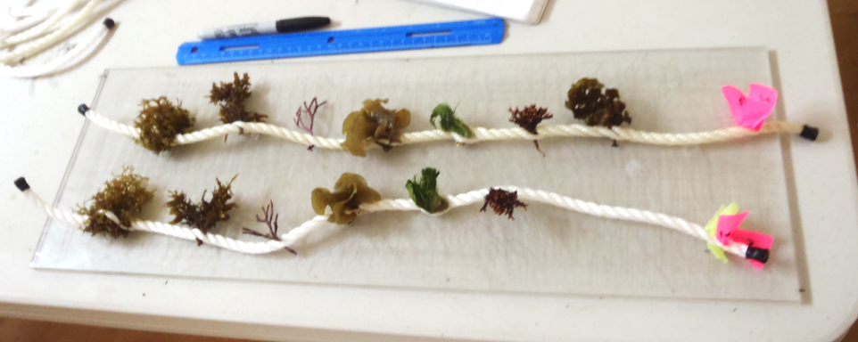Repeatfor all 25 rope strands, then bundle the free ends of each rope together, being careful to avoid damaging or dislodging plant pieces from the ropes. Return to the seawater bucket or table.

Figure : A weedpop ready for deployment. Note the even spacing of plants and flagging on top for easier relocation.

## Field: Day 1 — Deploying and initial scoring of weedpops:

1. Fill in the datasheet metadata*:* site name, MarineGEO site code, date, habitat type, etc…
2. Deploy weedpops by twisting open the strands at the free end of the rope (without plant pieces) and gripping the strands around a sturdy object such as piece of dead coral, stipate seaweed, or another anchored object. It is best to place the ropes on high points so that plant pieces are exposed visible to herbivores in the water column.
3. OPTIONAL – Deploy underwater video cameras close to ropes (~1-2 m) that 1 or more Weedpops fill the frame and herbivores can be identified in post-processing. Also, place a measuring stick directly adjacent to the Weedpops,and visible in the video,for estimating size of the consumers. Begin recording video at deployment and continue for 1 h.
4. One hour after all weedpops have been deployed, record the presence (“1”) or absence (“0”) of each functional group on each replicate on the datasheet. Individual species that are only partially consumed are counted as present. Denote any missing Weedpop ropes with an “M” on the datasheet.
5. Leave all weedpops in place for 24 h.

## Field: Day 2—Final scoring and retrieval of weedpops

### Return to the deployment site after approximately 24 h and re-locate each rope.

Score each plant piece as present (“1”) or absent (“0”); or score entire rope as missing (“M”).

1. Retrieve all ropes and any other materials (e.g., buoys, stakes) from the field.

## Post-processing:

### OPTIONAL – Scoring of video footage

1. Transfer video files from the video camera to a computer and name files according to MarineGEO standards: MarineGEO site code, specific location, date (YYYYMMDD), and protocol name (HerbivoryAssay), replicate number. For example: PAN-BDT_Bocas13-CasaBlanca_20181212_HerbivoiryAssay_1).
2. Immediately back up the video files in another secure location. Do not erase the videos from the camera until the files are named and stored securely in at least two places.
3. Before scoring the videos, tape a sheet of transparent plastic over the computer screen.
4. For each video file, use the ruler or measuring stick displayed during the initial deployment to make a scale on the transparent sheet using a marker.
5. Using the MarineGEO weedpop video data entry template, score each interaction between a herbivore and the plant bait by recording the video filename, timestamp, herbivore taxon (species or lowest taxon identifiable), and approximate length (using the scale), the species of the plant bait, and the number of bites taken. Repeat until the plant piece is entirely removed (it may help to start from the end of the video to see whether bait are still present after 1 h, and focusing only the bait that are eaten).
6. Repeat for all videos recorded.

## Data Submission

1. Scan the completed field datasheets as PDFs. Ensure that the filename includes the MarineGEO site code, specific location, date, and the name of the protocol (“Herbivory Weedpops”). Example: XXXXX
2. Enter the data, along with all metadata, from the field datasheet into the MarineGEO data entry template. Be sure to enter your full name and date of data entry, and fill in all columns to the best of your ability. Name the file to include the MarineGEO site code, specific location, date (yyyymmdd), and the name of the protocol (Example: “BEL-CBC_Site1_20180101_Herbivory video”)
3. Optional video footage should be named appropriately, backed up, and stored locally.
4. Email the PDF copies of all field datasheets, the completed data spreadsheet(s), and any additional notes or explanation to [marinegeo-data@si.edu](mailto:marinegeo-data@si.edu)

# Appendix A – Species belonging to each functional group by region:

|  |  |  |  |  |  |
| --- | --- | --- | --- | --- | --- |
|  |  | Region | | | |
|  |  | Caribbean | Equatorial Pacific | North West Pacific | North West Atlantic |
| **Functional Group** | Seagrass | Thalassia |  |  |  |
| Ephemeral Green Alga | Ulva |  |  |  |
| Tough Brown Canopy Alga | Sargassum  Turbinaria |  |  |  |
| Chemically Defended Brown Algae | Dictyota |  |  |  |
| Undefended Red alga | Hypnea  Acanthphora |  |  |  |
| Calcareous Green alga | Halimeda |  |  |  |
| **Common Standard** | Dried Undaria – aka Wakame | | | | |